**SOCCER EURO CUP 2016 DATABASE ANALYSIS**

**Introduction-**

Sample Database: soccer

Throughout this documentation we will be working with a sample database which will help to explain some basic to advanced level database concepts.

Sample Database description: The sample database represents some of the data storage and retrieval about a soccer tournament based on EURO CUP 2016. You might love football, and for all the football lovers we are providing detailed information about a football tournament. This design of the database will make it easier to understand the various questions that come to your mind about a soccer tournament.

**Description of tables:**

***soccer_country:***

* **country_id – this is a unique ID for each country**
* **country_abbr – this is the sort name of each country**
* **country_name – this is the name of each country**

***soccer_city:***

* **city_id – this is a unique ID for each city**
* **city – this is the name of the city**
* **country_id – this is the ID of the country where the cities are located and only those countries will be available which are in soccer_country table**

***soccer_venue:***

* **venue_id – this is a unique ID for each venue**
* **venue_name – this is the name of the venue**
* **city_id – this is the ID of the city where the venue is located and only those cities will be available which are in the soccer_city table**
* **aud_capicity – this is the capacity of audience for each venue**

***soccer_team:***

* **team_id – this is the ID for each team. Each teams are representing to a country which are referencing the country_id column of soccer_country table**
* **team_group – the name of the group in which the team belongs**
* **match_played – how many matches a team played in group stage**
* **won – how many matches a team won**
* **draw – how many matches a team draws**
* **lost – how many matches a team lose**
* **goal_for – how many goals a team conceded**
* **goal_agnst – how many goals a team scored**
* **goal_diff – the difference of goal scored and goal conceded**
* **points – how many points a team achieved from their group stage matches**
* **group_position – in which position a team finished their group stage matches**

***playing_position:***

* **position_id – this is a unique ID for each position where a player played**
* **position_desc – this is the name of the position where a player played**

***player_mast:***

* **player_id – this is a unique ID for each player**
* **team_id – this is the team where a player played, and only those teams which referencing the country_id column of the table soccer_country**
* **jersey_no – the number which labeled on the jersey for each player**
* **player_name – name of the player**
* **posi_to_play – the position where a player played, and the positions are referencing the position_id column of playing_position table**
* **dt_of_bir – date of birth of each player**
* **age – approximate age at the time of playing the tournament**
* **playing_club – the name of the club for which a player was playing at the time of the tournament**

***referee_mast:***

* **referee_id – this is the unique ID for each referee**
* **referee_name – name of the referee**
* **country_id – the country, where a referee belongs and the countries are those which referencing the country_id column of soccer_country table**

***match_mast:***

* **match_no – this if the unique ID for a match**
* **play_stage – this indicates that in which stage a match is going on, i.e. G for Group stage, R for Round of 16 stage, Q for Quarter final stage, S for Semi Final stage, and F for Final**
* **play_date – date of the match played**
* **results – the result of the match, either win or draw**
* **decided_by – how the result of the match has been decided, either N for by normally or P for by penalty shootout**
* **goal_score – score for a match**
* **venue_id – the venue where the match played and the venue will be one of the venue referencing the venue_id column of soccer_venue table**
* **referee_id – ID of the referee who is selected for the match which referencing the referee_id column of referee_mast table**
* **audence – number of audience appears to watch the match**
* **plr_of_match – this is the player who awarded the player of a particular match and who is selected a 23 men playing squad for a team which referencing the player_id column of player_mast table**
* **stop1_sec – how many stoppage time ( in second) have been added for the 1st half of play**
* **stop2_sec – how many stoppage time ( in second) have been added for the 2nd half of play**

***coach_mast:***

* **coach_id – this is the unique ID for a coach**
* **coach_name – this is the name of the coach**

***asst_referee_mast:***

* **ass_ref_id – this is the unique ID for each referee assists the main referee**
* **ass_ref_name – name of the assistant referee**
* **country_id – the country where an assistant referee belongs and the countries are those which are referencing the country_id column of soccer_country table**

***match_details:***

* **match_no – number of the match which is referencing the match_no column of match_mast table**
* **play_stage - stage of the match, i.e. G for group stage, R for Round of 16, Q for Quarter Final, S for Semi final and F for final**
* **team_id – the team which is one of the playing team and it is referencing the country_id column of soccer_country table**
* **win_lose – team either win or lose or drawn indicated by the character W, L, or D**
* **decided_by - how the result achieved by the team, indicated N for normal score or P for penalty shootout**
* **goal_score – how many goal scored by the team**
* **penalty_score – how many goal scored by the team in penalty shootout**
* **ass_ref – the assistant referee assist the referee which are referencing the ass_ref_id column of asst_referee_mast table**
* **player_gk - the player who is keeping the goal for the team, is referencing the player_id column of player_mast table**

***goal_details:***

* **goal_id – this is the unique ID for each goal**
* **match_no – this is match_no which is referencing the match_no column of match_mast table**
* **player_id - this is the ID of a player who is selected for the 23 men squad of a team for the tournament and which is referencing the player_id column of player_mast table**
* **team_id – this is the ID of each team who are playing in the tournament and referencing the country_id column of soccer_country table**
* **goal_time – this is the time when the goal scored**
* **goal_type – this is the type of goal which came in normally indicated by N or own goal indicating by O and goal came from penalty indicated by P**
* **play_stage – this is the play stage in which goal scored, indicated by G for group stage, R for round of 16 stage, Q for quarter final stage, S for semifinal stage and F for final match**
* **goal_schedule – when the goal came, is it normal play session indicated by NT or in stoppage time indicated by ST or in extra time indicated by ET**
* **goal_half – in which half of match goal came**

***penalty_shootout:***

* **kick_id – this is unique ID for each penalty kick**
* **match_no - this is the match_no which is referencing the match_no column of match_mast table**
* **team_id – this is the ID of each team who is playing in the tournament and referencing the country_id column of soccer_country table**
* **player_id - this is the ID of a player who is selected for the 23 men squad of a team for the tournament and which is referencing the player_id column of player_mast table**
* **score_goal – this is the flag Y if able to score the goal or N when not**
* **kick_no – this is the kick number for the kick of an individual match**

***player_booked:***

* **match_no - this is the match_no which is referencing the match_no column of match_mast table**
* **team_id – this is the ID of each team who are playing in the tournament and referencing the country_id column of soccer_country table**
* **player_id - this is the ID of a player who is selected for the 23 men squad of a team for the tournament and which is referencing the player_id column of player_mast table**
* **booking_time – this is the time when a player booked**
* **sent_off – this is the flag Y when a player sent off**
* **play_schedule – when a player booked, is it in normal play session indicated by NT or in stoppage time indicated by ST or in extra time indicated by ET**
* **play_half – in which half a player booked**

***player_in_out:***

* **match_no - this is the match_no which is referencing the match_no column of match_mast table**
* **team_id – this is the ID of each team who are playing in the tournament and referencing the country_id column of soccer_country table**
* **player_id - this is the ID of a player who is selected for the 23 men squad of a team for the tournament and which is referencing the player_id column of player_mast table**
* **in_out – this is the flag I when a player came into the field or O when go out from the field**
* **time_in_out – when a player come into the field or go out from the field**
* **play_schedule – when a player come in or go out of the field, is it in normal play session indicated by NT or in stoppage time indicated by ST or in extra time indicated by ET**
* **play_half - in which half a player come in or go out**

***match_captain:***

* **match_no - this is the match_no which is referencing the match_no column of match_mast table**
* **team_id – this is the ID of each team who are playing in the tournament and referencing the country_id column of soccer_country table**
* **player_captain - the player who represents as a captain for a team, is referencing the player_id column of player_mast table**

***team_coaches:***

* **team_id – this is the ID of a team who is playing in the tournament and referencing the country_id column of soccer_country table**
* **coach_id – a team may be one or more coaches, this indicates the coach(s) who is/are coaching the team is referencing the coach_id column of coach_mast table**

***penalty_gk:***

* **match_no - this is the match_no which is referencing the match_no column of match_mast table**
* **team_id – this is the ID of each team who are playing in the tournament and referencing the country_id column of soccer_country table**
* **player_gk - the player who kept goal at the time of penalty shootout, is referencing the player_id column of player_mast table**

**Question And Answer-**

Question1-From the following table, write a SQL query to count the number of venues for EURO cup 2016. Return number of venues

Query-select count(venue_id) from soccer_venue

Solution-

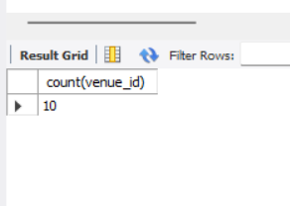

Analysis- from this data we analyze that there is total 10 venues for euro cup 2016

Question2-From the following table, write a SQL query to count the number of countries that participated in the 2016-EURO Cup.

Query-select count(distinct(team_id)) from player_mast

Solution-

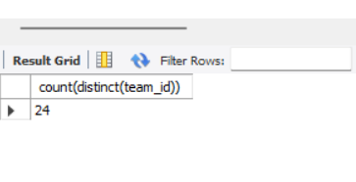

Analysis-from this query we found that there are total 24 countries in euro cup 2016

Question3-From the following table, write a SQL query to find the number of goals scored within normal play during the EURO cup 2016

Query-select count(goal_id) from goal_details

Solution-

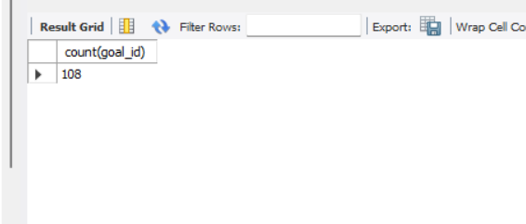

Analysis-from this query we found that total goals is 108 in euro cup

Question4- From the following table, write a SQL query to find the number of matches that ended with a result.

Query- From the following table, write a SQL query to find the number of matches that ended with a result.

Solution-

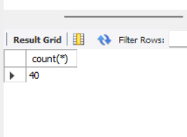

Analysis-from this query we analyse that 40 teams won their matches

Question5- From the following table, write a SQL query to find the number of matches that ended in draws

Query- select count(*) from match_mast where results='DRAW'

Solution-

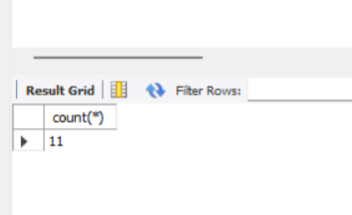

Analysis-11 teams have drawn their matches in euro cup 2016

Question6- From the following table, write a SQL query to find out when the Football EURO cup 2016 will begin.

Query- select play_date as "beggining Date" from match_mast where match_no=1

Solution-

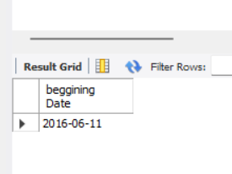

Analysis- beginning date of euro cup 2016 is 2016-06-11

Question7- From the following table, write a SQL query to find the number of self-goals scored during the 2016 European Championship.

Query- select count(goal_type) from goal_details where

goal_type='O'

Solution-

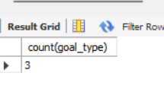

Analysis-we analyze that 3 teams scored an own goal scored in eurocup

Quesion8- From the following table, write a SQL query to count the number of matches ended with a results in-group stage

Query- select count(*) from match_mast where play_stage='G'

and results='WIN'

solution-

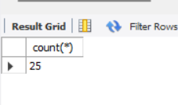

Analysis-we analyze that 25 teams won in their group stage

Question9- From the following table, write a SQL query to find the number of matches that resulted in a penalty shootout.

Query- select count(distinct(match_no)) as count from penalty_shootout

Solution-

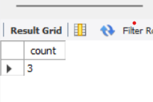

Analysis-from this query we found that 3 matches ended in penalty shootout

Question10- From the following table, write a SQL query to find number of matches decided by penalties in the Round 16

Query- select count(*) from match_mast where decided_by='P' and play_stage='R'

Solution-

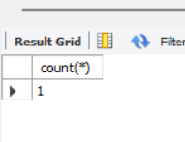

Analysis- only 1 match was decided by penalty in round16

Question11-  From the following table, write a SQL query to find the number of goals scored in every match within a normal play schedule. Sort the result-set on match number. Return match number, number of goal scored.

Query- select match_no, count(*) from goal_details group by match_no order by match_no

Solution-

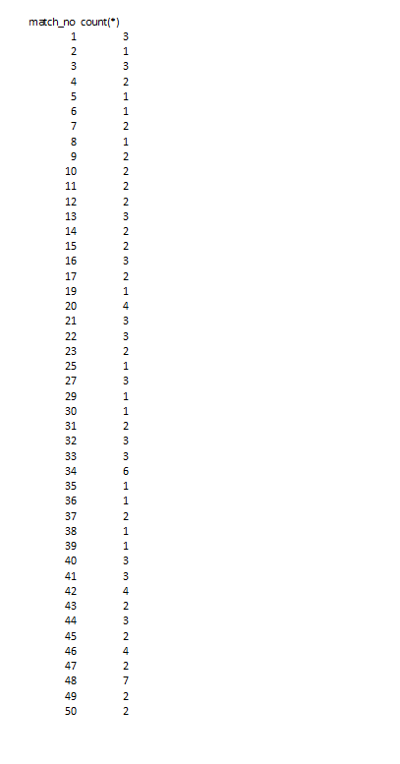

Analysis-the data shown the number of goals scored in normal play

Question12-  From the following table, write a SQL query to find the matches in which no stoppage time was added during the first half of play. Return match no, date of play, and goal scored

Query- select match_no,play_date,goal_score from match_mast where stop1_sec='0'

Solution-

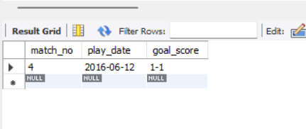

Analysis-from this we found the above data where no stoppage time was added in 1st half

Question13- From the following table, write a SQL query to count the number of matches that ended in a goalless draw at the group stage. Return number of matches.

Query- select count(distinct(match_no)) from match_details where win_lose='D' and goal_score='0' and play_stage='G'

Solution-

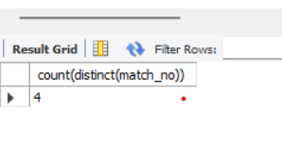

Question14-From the following table, write a SQL query to calculate the number of matches that ended in a single goal win, excluding matches decided by penalty shootouts. Return number of matches

Query-select count(distinct(match_no)) as "Count" from match_details

where goal_score=1 and decided_by<>'P' and win_lose='W'olution-

Solution-

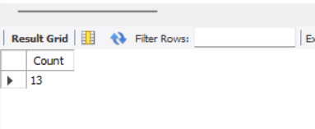

Analysis-there are 13 matches that that ended in a single goal win, excluding matches decided by penalty shootouts

Question15- From the following table, write a SQL query to count the number of players replaced in the tournament. Return number of players as "Player Replaced".

Query- select count(player_id) as "Player Relaced" from player_in_out where in_out='O'

Solution-

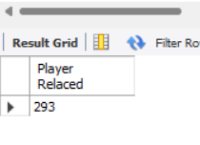

Analysis- from this we analyse that 293 player were replaced

Question16- From the following table, write a SQL query to count the total number of players replaced during normal playtime. Return number of players as "Player Replaced"

Query- select count(player_id) as "Player Relaced" from player_in_out where in_out='O' and play_schedule='NT'

Solution-

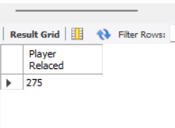

Analysis- 275 players were replaced during normal playtime in euro cup 2016

Question17- From the following table, write a SQL query to count the number of players who were replaced during the stoppage time. Return number of players as "Player Replaced"

Query- select count(player_id) as "Player Relaced" from player_in_out where in_out='O' and play_schedule='ST'

Solution-

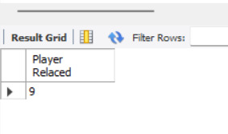

Analysis- 9 players were replaced during the stoppage time in euro cup 2016

Question18- From the following table, write a SQL query to count the number of players who were replaced during the first half. Return number of players as "Player Replaced"

Query- select count(player_id) as "Player Relaced" from player_in_out

where play_half='1' and in_out='I' and play_schedule='NT'

Solution-

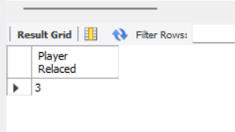

Analysis-total 3 players were replaced during the first half of euro cup 2016

Question19- From the following table, write a SQL query to count the total number of goalless draws played in the entire tournament. Return number of goalless draws.

Query- select count(distinct(match_no)) from match_details where win_lose='D' and goal_score=0

Solution-

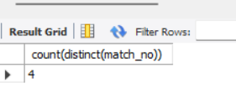

Analysis- in following query we found that there are 4 matches with draws and 0 goal scored by either team

Question20- From the following table, write a SQL query to calculate the total number of players who were replaced during the extra time.

Query- select count(player_id) from player_in_out where in_out='I' and play_schedule='ET'

Solution-

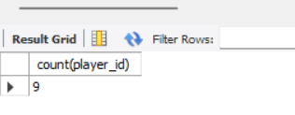

Analysis- total 9 players were replaced during extra time

Question21- From the following table, write a SQL query to count the number of substitutes during various stages of the tournament. Sort the result-set in ascending order by play-half, play-schedule and number of substitutes happened. Return play-half, play-schedule, number of substitutes happened

Query- select play_half, play_schedule, count(*) from player_in_out where in_out='I' group by play_half,play_schedule order by play_half, play_schedule, count(*)

Solution-

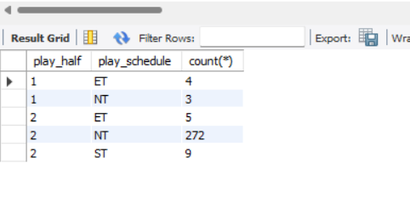

Analysis -The query aggregates substitute occurrences by play half and schedule, providing insights into substitution patterns throughout the tournament stages. Sorting helps identify trends and key moments in matches based on substitution frequency.

Question22-From the following table, write a SQL query to count the number of shots taken in penalty shootouts matches. Number of shots as "Number of Penalty Kicks".

Query-select count(team_id) as "Number Of Penalty Kicks " from penalty_shootout

Solution-

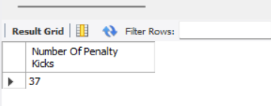

Analysis- total 37 penalty kicks were taken in the game

Question23-From the following table, write a SQL query to count the number of shots that were scored in penalty shootouts matches. Return number of shots scored goal as "Goal Scored by Penalty Kicks".

Query-select count(team_id) as "Goal Scored by Penalty Kicks " from penalty_shootout where score_goal='Y'

Solution-

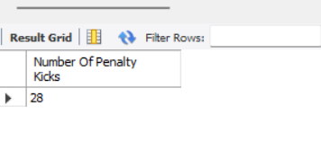

Analysis-total 28 goals were scored by penalty kicks

Question24-From the following table, write a SQL query to count the number of shots missed or saved in penalty shootout matches. Return number of shots missed as "Goal missed or saved by Penalty Kicks".

Query-select count(team_id) as "Goal Scored by Penalty Kicks " from penalty_shootout where score_goal='N'

Solution-

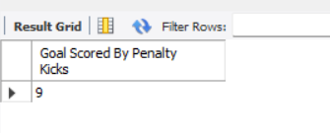

Analysis- total 9 goals were missed through penalties

Question25- From the following table, write a SQL query to find the players with shot numbers they took in penalty shootout matches. Return match_no, Team, player_name, jersey_no, score_goal, kick_no.

Query-select penalty_shootout.match_no,soccer_country.country_name,

player_mast.player_name,player_mast.jersey_no,

penalty_shootout.score_goal,penalty_shootout.kick_no

from penalty_shootout,player_mast,soccer_country

where soccer_country.country_id=penalty_shootout.team_id

and penalty_shootout.player_id=player_mast.player_id

Solution-

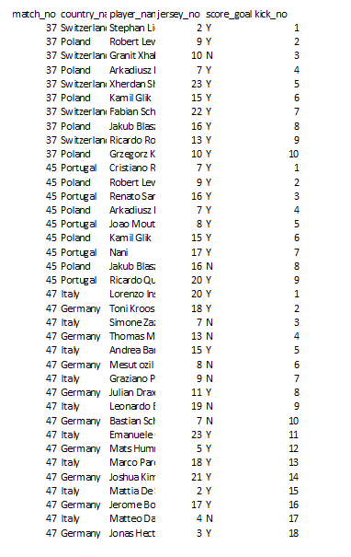

Analysis- from this we analyze that the above listed countries took penalty shootout in euro cup 2016

Question26-From the following table, write a SQL query to count the number of penalty shots taken by each team. Return country name, number of shots as "Number of Shots"

Query-select soccer_country.country_name,count(penalty_shootout.team_id) from soccer_country,penalty_shootout where soccer_country.country_id=penalty_shootout.team_id group by country_name

Solution-

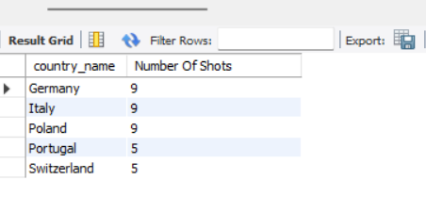

Analysis-

Question27- From the following table, write a SQL query to count the number of bookings during stoppage time.

Query-select count(*) from player_booked where play_schedule='ST'

Solution-

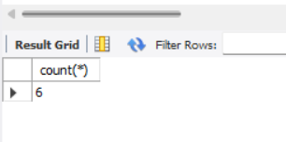

Analysis- We analyze that 6 players were booked during stoppage time

Question28-From the following table, write a SQL query to count the number of bookings in each half of play within the normal play schedule. Return play_half, play_schedule, number of booking happened.

Query-select play_half,play_schedule,count(*) from player_booked where play_schedule='NT' group by play_half

Solution-

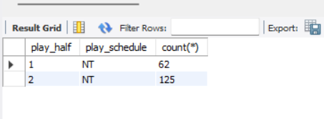

Analysis-in this we found that only 2 bookings were done in normal schedule

Question29-From the following table, write a SQL query to count the number of bookings that happened in extra time.

Query-select count(match_no) from player_booked where play_schedule='ET'

Solution-

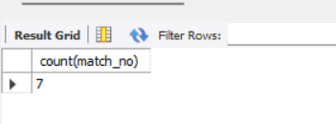

Analysis-in this we found that 7 bookings were done in extra time

Question30-From the following table, write a SQL query to find out which teams played the first match of the 2016 Euro Cup. Return match number, country name.

Query-select m.match_no,s.country_name from match_details m, soccer_country s where m.team_id=s.country_id and m.match_no='1'

Solution-

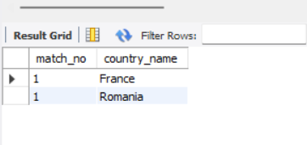

Analysis- France and Romania are the countries having first match in euro cup 2016

Question31-From the following tables, write a SQL query to find the winner of EURO cup 2016. Return country name.

Query-select s.country_name from soccer_country s,match_details m where s.country_id=m.team_id and m.play_stage='F' and m.win_lose='W'

Solution-

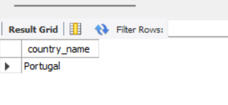

Analysis- from this we found that Portugal won the euro cup of 2016

Question32-From the following table, write a SQL query to find the highest audience match. Return match_no, play_stage, goal_score, audience.

Query-select match_no,play_stage,goal_score,audence from match_mast where audence=(select max(audence) from match_mast)

Solution-

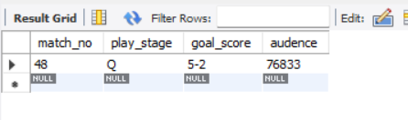

Analysis-this shows that 48 match number have the highest audience

Question33-From the following tables, write a SQL query to find the match number in which Germany played against Poland. Group the result set on match number. Return match number.

Query-